**FSD Laboratory 04**

**Aim:** Write server-side script in PHP to perform form validation and create database application using PHP and MySQL to perform insert, update, delete and search operations.

**Objectives:**

1. To understand Server-side Scripting.
2. To learn database connectivity using PHP-MySQL.
3. To perform insert, update, delete and search operations on database.

**Theory:**

1. PHP Architecture.

PHP (Hypertext Preprocessor) is a server-side scripting language widely used for web development. Its architecture typically involves the following components:

* Web Server: PHP scripts are executed on a web server, which receives requests from clients (e.g., browsers) and sends responses.
* PHP Engine: PHP scripts are processed by the PHP engine on the server. The engine interprets PHP code, executes it, and generates HTML for the response.
* Database: PHP often interacts with databases (e.g., MySQL, PostgreSQL) to store and retrieve data.
* Client: The client's browser or application sends HTTP requests to the server.
* File System: PHP scripts can read and write files on the server's

1. Steps for Database connectivity in PHP.

To connect to a database in PHP, you typically follow these steps:

1. Choose a Database: Select the database management system (DBMS) you want to connect to (e.g., MySQL, PostgreSQL).
2. Install Database Extension: Ensure the relevant PHP database extension is installed and enabled (e.g., mysql for MySQL).
3. Establish Connection: Use PHP functions (e.g., mysqli_connect) to create a connection to the database server.
4. Execute Queries: Write SQL queries and execute them to interact with the database (e.g., SELECT, INSERT, UPDATE, DELETE).
5. Handle Errors: Implement error handling to manage database connection issues or query errors.
6. Close Connection: Always close the database connection when done to free up resources.

**FAQ:**

1. What are the advantages of Server-side Scripting?

Server-side scripting offers several advantages, including:

* Dynamic Content: The ability to generate dynamic web content based on user input or database data.
* Data Processing: Processing and manipulating data on the server, making it secure and efficient.
* Database Interaction: Interaction with databases to store and retrieve data.
* Session Management: Management of user sessions and user-specific data.
* Security: Enhanced security as sensitive operations are performed on the server, not exposed in client-side code.

1. What is XAMPP and phpMyAdmin?

**XAMPP**: XAMPP is a cross-platform open-source web server solution that includes Apache, MySQL, PHP, and Perl. It provides an easy way to set up a local web development environment for testing and development purposes.

**phpMyAdmin**: phpMyAdmin is a web-based database management tool for MySQL. It allows users to manage databases, execute SQL queries, and perform various administrative tasks through a web interface.

1. What are the two ways to connect to a database in PHP?

The two common ways to connect to a database in PHP are:

* **MySQLi Extension:** MySQL Improved (MySQLi) is a modern and recommended extension for MySQL database connections in PHP. It offers enhanced security and features.
* **PDO (PHP Data Objects)**: PDO is a database abstraction layer that provides a consistent interface to interact with various database management systems, including MySQL, PostgreSQL, and SQLite. It is more versatile and can work with different database types.

**Output: Screenshots of the output to be attached.**

**Sample Problem Statements:**

PHP CRUD Operations

1.Student can create a PHP form or use existing/ implemented HTML form for Student’s Registration System with the fields mentioned: First name,Last name, Roll No/ID, Password, Confirm Password,Contact number and perform following operations

1.Insert student details -First name,Last name, Roll No/ID, Password, Confirm Password,Contact number

2.Delete the Student records based on Roll no/ID

3.Update the Student details based on Roll no/ID- Example students can update their contact details based on searching the record with Roll no.

4.Display the Updated student details or View the Students record in tabular format.

Apply Form Validation on the necessary fields using PHP/Javascript

2. Student can create a PHP form or use existing/ implemented HTML form for Library Management System with the fields mentioned: Book name, ISBN No, Book title, Author name , Publisher name and perform following operations

1.Insert Book details -Book name, ISBN No, Book title, Author name, Publisher name

2.Delete the Book records based on ISBN No

3.Update the Book details based on ISBN No- Example students can update wrong entered book details based on searching the record with ISBN No.

4.Display the Updated Book details or View the Book Details records in tabular format.

Apply Form Validation on the necessary fields using PHP/Javascript

3. Student can create a PHP form or use existing/ implemented HTML form for Employee Management System with the fields mentioned: Employee name, Employee ID, Department_name, Phone number , Joining Date and perform following operations

1.Insert Employee details -Employee name, Employee ID, Department_name, Phone number , Joining Date

2.Delete the Employee records based on Employee ID

3.Update the Employee details based on Employee ID- Example students can update Employee details based on searching the record with Employee ID.

4.Display the Updated Employee details or View the Employee Details records in tabular format.

Apply Form Validation on the necessary fields using PHP/Javascript

4. Student can create a PHP form or use existing/ implemented HTML form for Flight Booking Management System with the fields mentioned: Passenger name, From, to, date,Departure date,Arrival date, Phone number , Email ID and perform following operations

1.Insert Passenger details -Passenger name, From, to, date,Departure date,Arrival date, Phone number , Email ID

2.Delete the Passenger records based on Phone Number

3.Update the Passenger details based on Phone Number - Example students can update Flight Booking details based on searching the record with Phone Number.

4.Display the Updated Flight Booking details or View the Flight Booking Details records in tabular format.

Apply Form Validation on the necessary fields using PHP/Javascript.

Technologies Student Should Use:

XAMPP

PHP for Server-side Scripting

MySQL as a backend Database

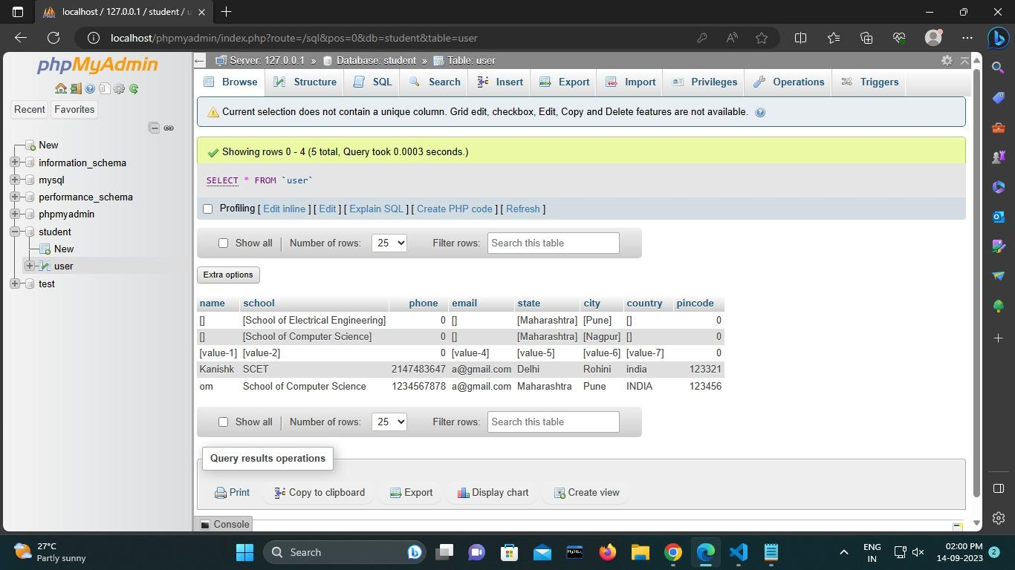

Code Screenshots:

1) Html script: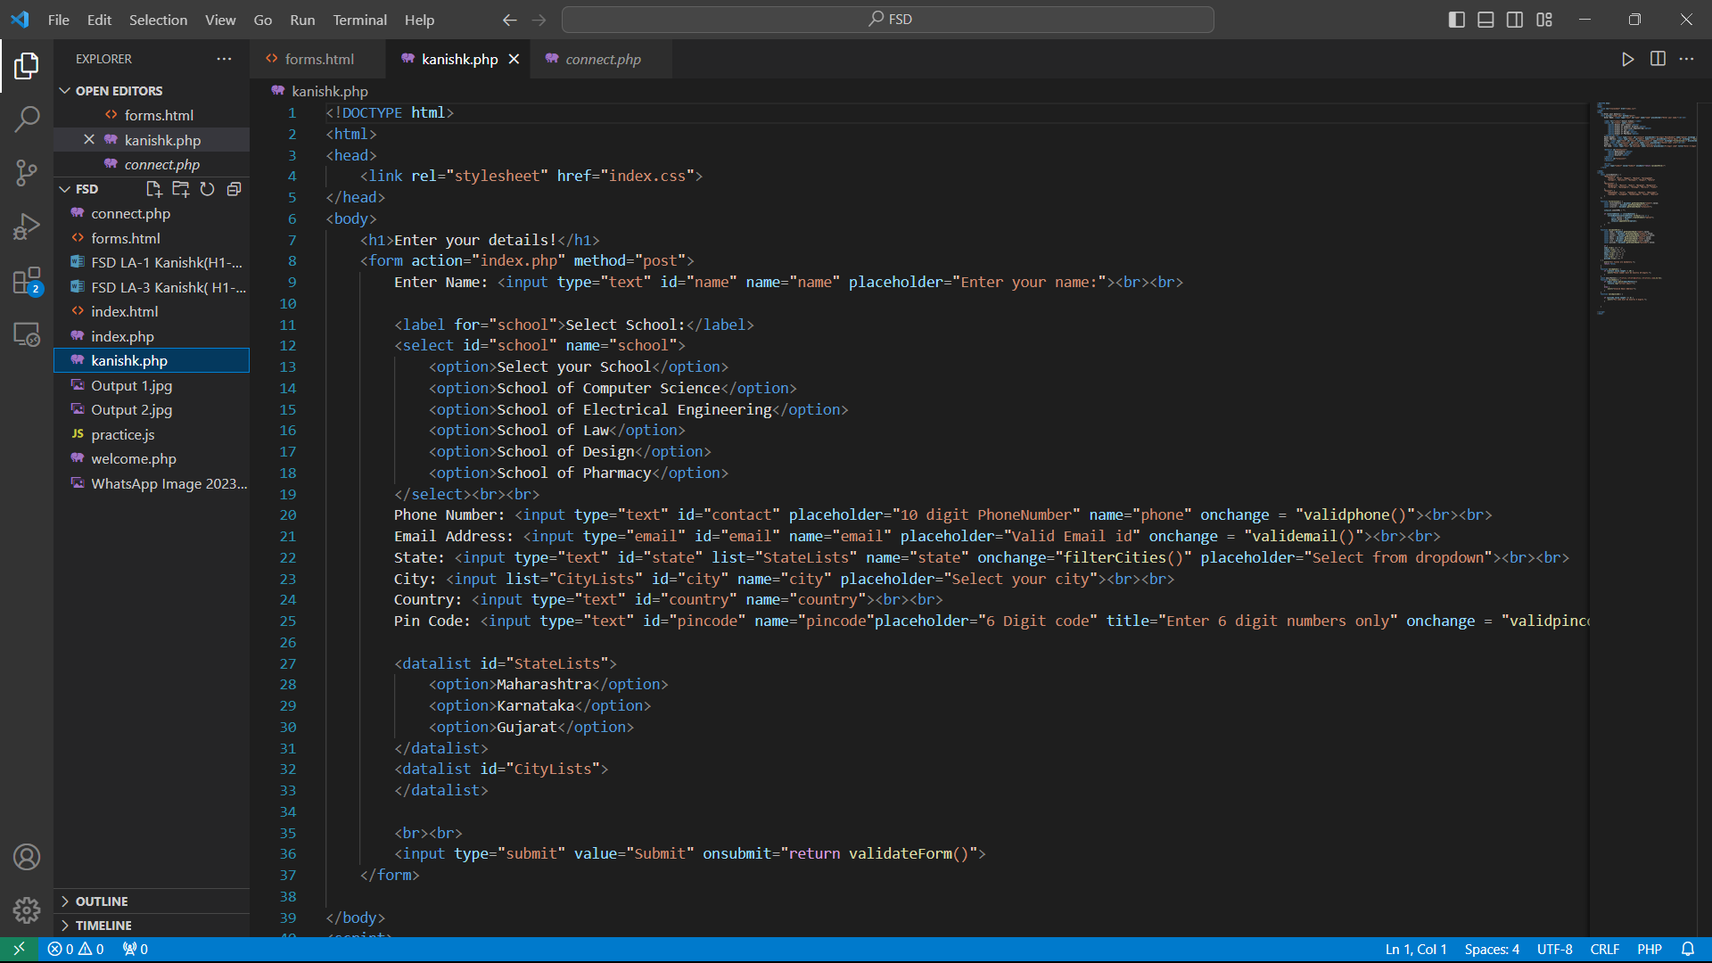

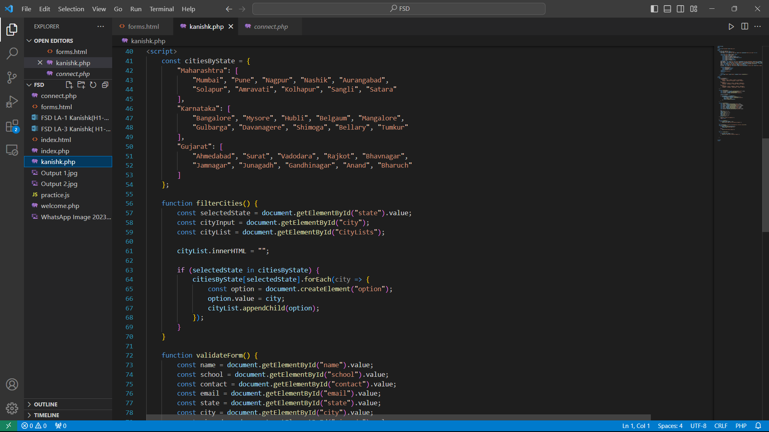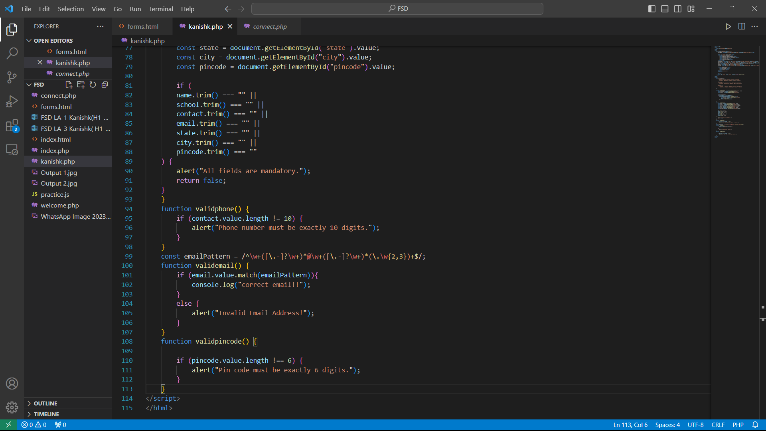

2) Php Screenshots:

